Report of Lectures/Orientations/Workshops/Other Activities of S. B. Deorah College

1. Name of the Event: | World Day for Cultural Diversity for Dialogue and Development
2. Date and Time: | 21/05/2022
3. Venue: | Conference Room
4. Organized by Department/ Cell/ Committee: | Dept. of Political Science
5. Name of the Convenor: | Dr. Nabanita Bhuyan
6. Resource Person and Organization Details: | None
7. Objective of the event: | To celebrate and emphasise the importance of diversity in enriching our lives
8. Number of Participants: | 31
9. Category of Participants (e.g. Students/Faculty etc.): | Students and Faculty
10. A brief report of the event:
The Dept of Political Science observed the World Day for Cultural Diversity on 21st May 2022. Significance of this day is that the world society is multinational and this diversity is very essential for cultural exchanges for achieving peace and sustainable development. This year’s theme of World Day for Cultural Diversity was “Building a Shared Future for all Life”. Celebration of this day is very important because it helps us to learn from each other and understand that everyone is unique and special in their own way. This day is recognised by UNO as an observance day for promotion of diversity. In today’s programme, students from different ethnic groups from Northeast India performed and presented different programmes showcasing their cultural diversities. Teachers also delivered speech on the importance and significance of the day and the role which can be played by cultural exchanges in maintaining unity and peace in the society.

Signature of Convenor

Photographs of the event:
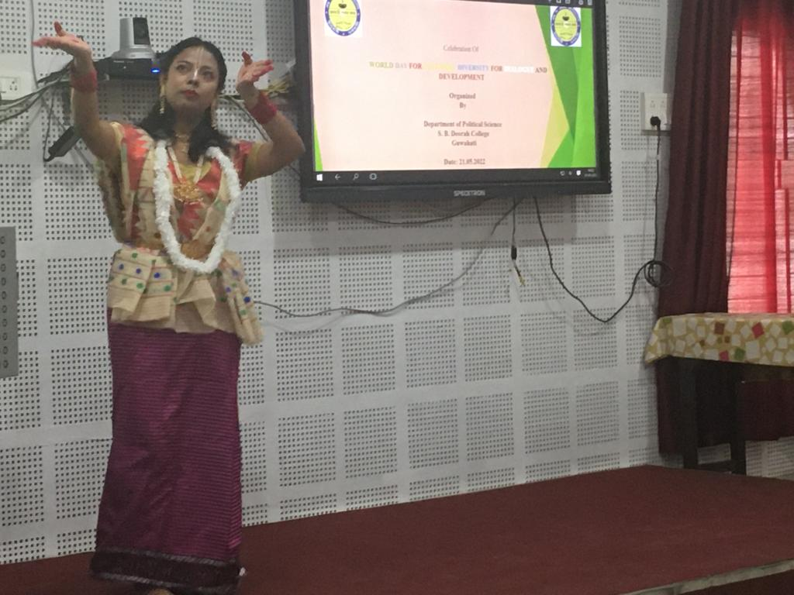
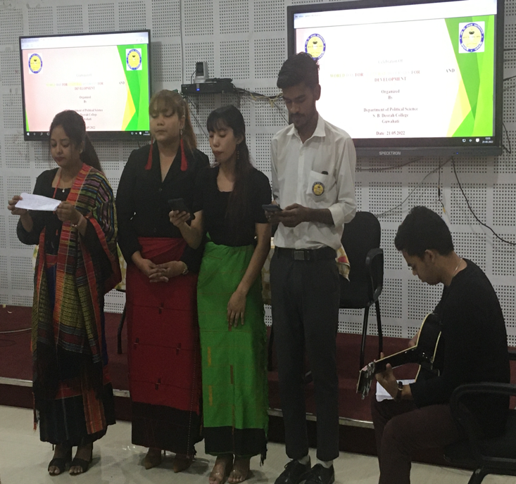

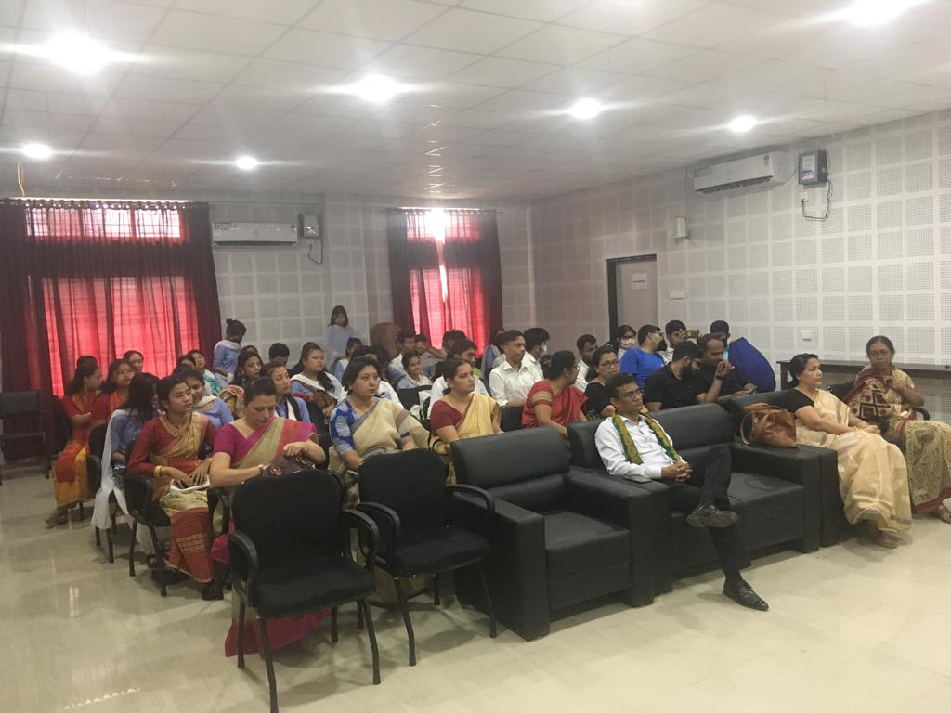
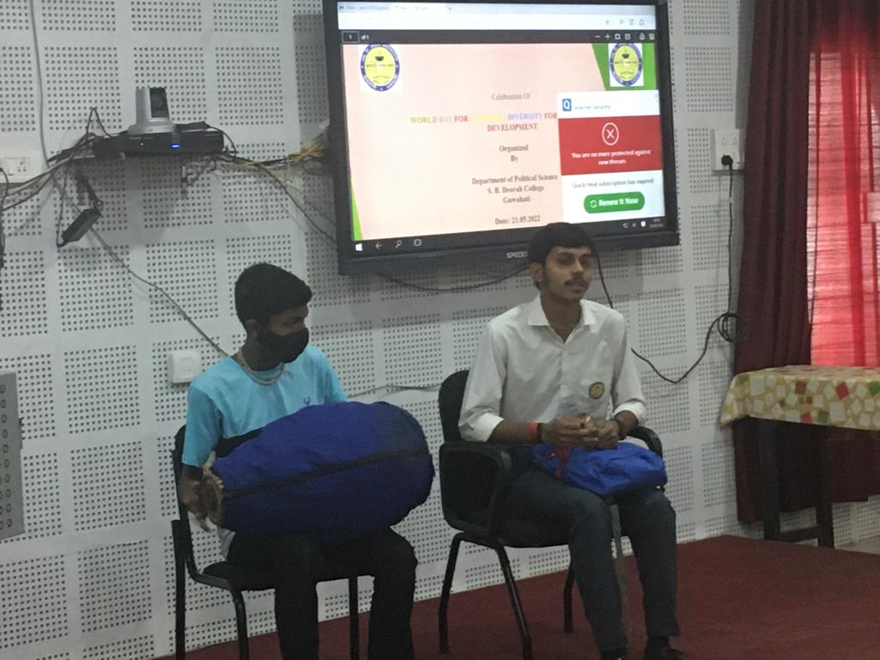

Name & Signatures of Participants:
