Inauguration of wall magazine for2024-2025
Date:-28/08/2025
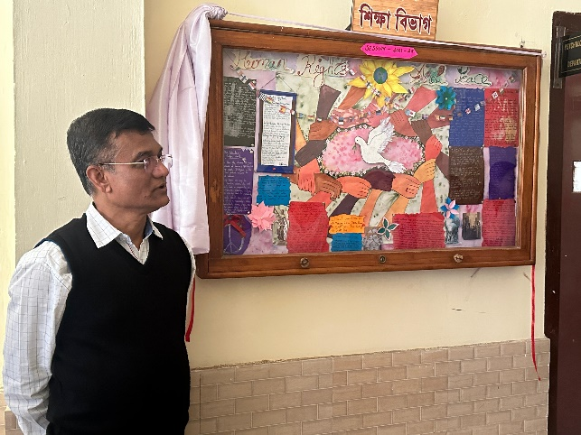
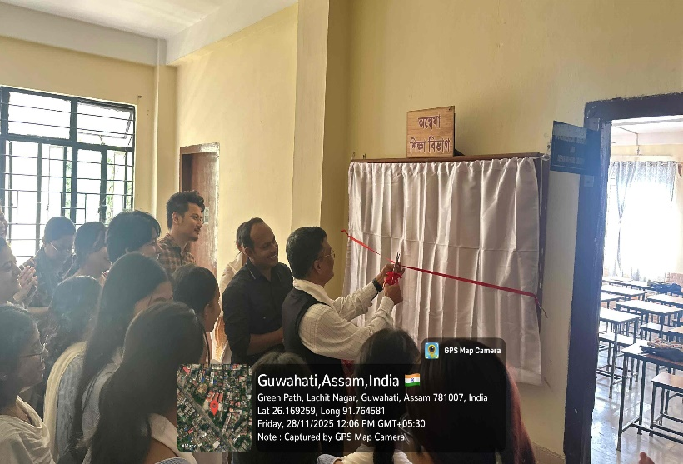
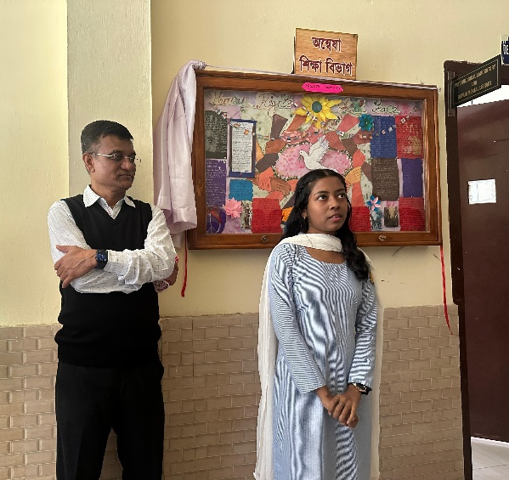
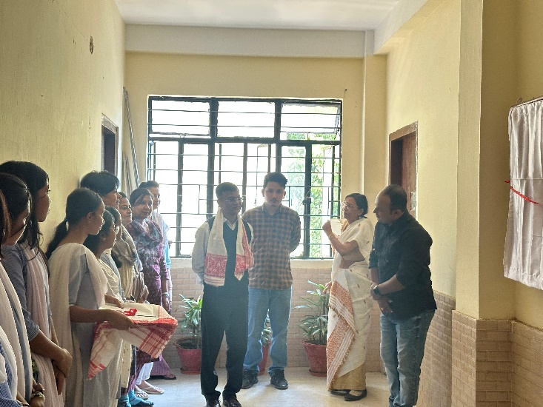
The departmental Wall Magazine of 2024-25 was inaugurated on 28th November, 2025at 12 noon Dr. Dharmendra Nath Principal of the college inaugurated the wall magazine. The theme of the wall magazine was 'Human Rights and Peace Mr. Sajidur Rahman, Asstt Professor of the department delivered the welcome address and spoke on the theme of the wall magazine. Dr. Dharmendra Nath delivered the inaugural speech and he encouraged the major students of B.A. 5th Semester class who prepared the wall magazine. The faculty members of English and Political Science department were present in the function. The students of different departments were abo present.

