_____________________________________________________________________________________

This is to notify all the concerned that the Department of Education, in association with NSS Unit, S.B.Deorah College organizes free counselling programme in every first and third Wednesday of each month. Mrs. Gayatri Borah, Clinical Psychologist, Guwahati takes counselling in the college. Thereby, interested students are asked to contact Mrs. Ajanta Saikia, HoD, Department of Education, S.B.D.C.

Contact Number: 9435491223
(Mrs. Ajanta Saikia)

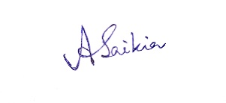 (Mrs. Ajanta Saikia)
HoD,Department of Education
S.B.Deorah College,
Ulubari, Ghy-7

