_____________________________________________________________________________________
Attendance of B.A 6th Semester Major Students in the month of March,2026
Roll-No | Name | Total No. of classes held in the  month of March,2026  (41)
Roll-No | Name | No. of classes  attended | Percentage (%)
03 | DIPIKA BORA | 39 | 95
11 | DHAMI AIENA CHAKMA | 15 | 37
19 | SHRUTI DEKA | 17 | 41
30 | JUBILI DAS | 31 | 76
67 | TINA BAISHYA | 31 | 76
87 | KACHANGTHALUI PAMEI | 33 | 80
90 | L. ALBINA CHAKMA | 30 | 73
125 | EDWIN NAMPUI | 16 | 39
194 | ARSIKHA K. MARAK | 22 | 54
240 | ABAULE NEWME | 23 | 56
248 | NUSAING GIRISA | 35 | 85
305 | BARSHA DAS | 23 | 56

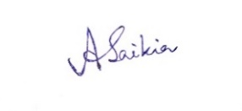
(Mrs. Ajanta Saikia)
HoD, Department of Education
S.B.Deorah College

