_____________________________________________________________________________________
Date: 16/05/2026

This is to notify all the 4th semester Major students of the Department of Education that the inauguration programme of wall magazine will be held on 20th May, 2026 at 12 p.m. Hereby, all the major students of fourth semester are instructed to be present on the day.

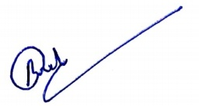
(Dr. Rumamani Deka)
HoD,Department of Education
S.B.Deorah College,
Ulubari, Ghy-7

